

**Discipline**

**Layouts and Frames**

**CS5201**

Stage-1

**Sheikh Muhammed Tadeeb (AU19B1014)**

* **Layouts and Frames:**

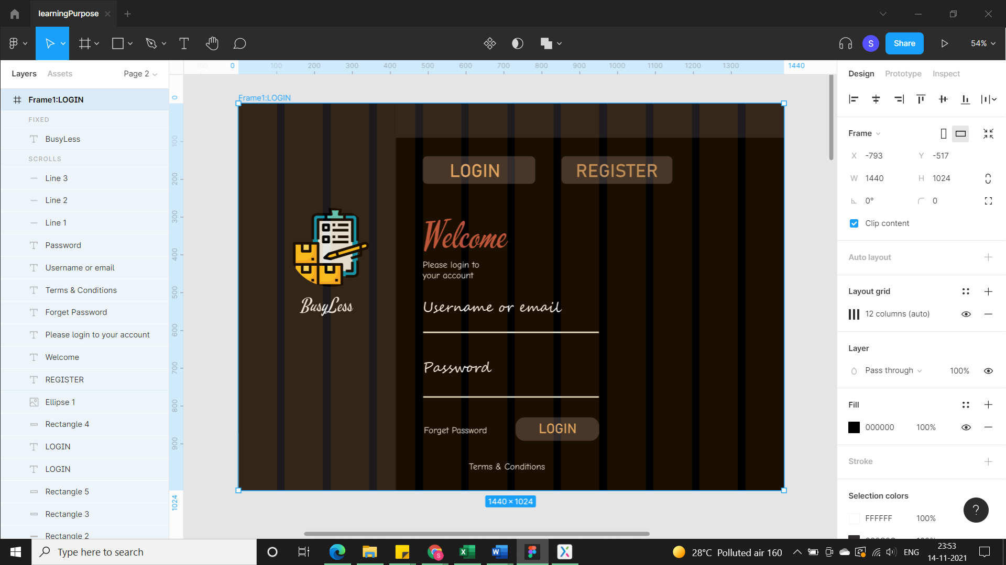

1026×91

297×73

297×73

161×66

415×1024

223×208

227×127

404×44

464×0

231×30

223×64

231×30

Note: I had divided the whole frame into grid layout of 12 columns (Standard way) with gutter 20. All the layout dimensions can be seen in above image. Similarly, I did for all the frames.